MODULE 4 – INTRODUCTION TO DBMS

LAB EXERCISES

11. Data Control Language – DCL
Lab 1.
Grant SELECT permission to a user named librarian on the books table.
Ans.
1. GRANT SELECT ON library_db.books TO 'librarian '@'localhost';
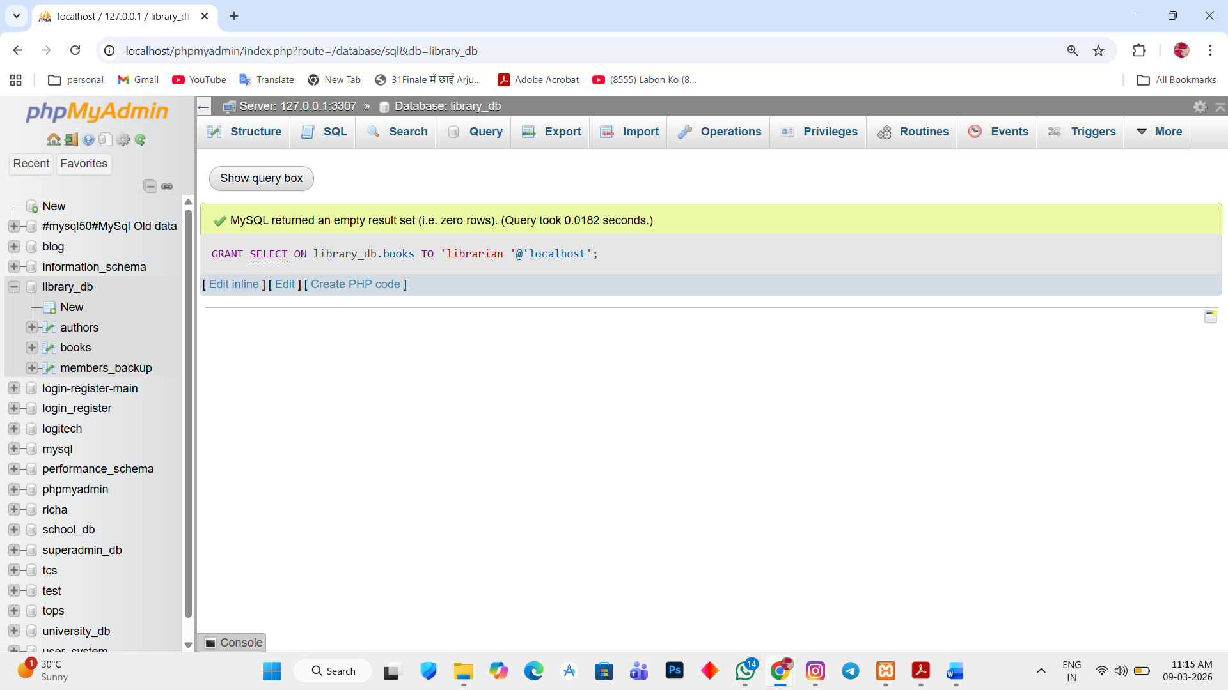

Lab 2.
Grant INSERT and UPDATE permission to the user admin on the members table.
Ans.
1. GRANT INSERT, UPDATE ON library_db.members_backup TO 'admin'@'localhost';

